Boyd Gibson (Student)

User Manual

Contents

Installation 2

Log In 4

Create Account 5

Questions 1 6

Questions 2 7

Questions 3 8

Questions 4 9

Questions 5 10

Results 11

Home 11

Pt Session 11

Training Plans 12

Featured 12

Gym 13

Home 13

How To Use 14

Exercise Tutorial 15

Profile 17

Settings 18

# Installation

First you need to move the graded unit installer that is located in the Program folder to your desktop. From there double click and click yes when it asks you to make changes. Once you have done that this screen will pop up:

Click browse and make a new folder in your desktop.

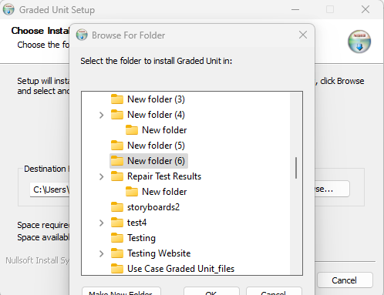

From there click install and wait a few minutes

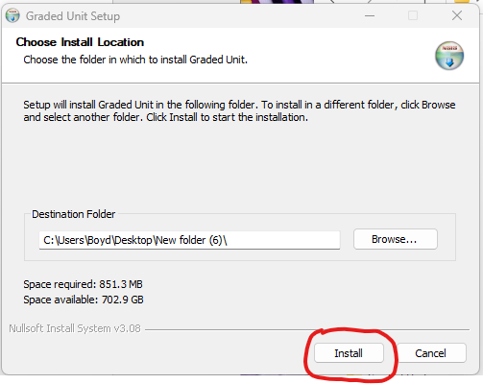

Once it has finished downloading click close. Now find and open the file that you downloaded it in.

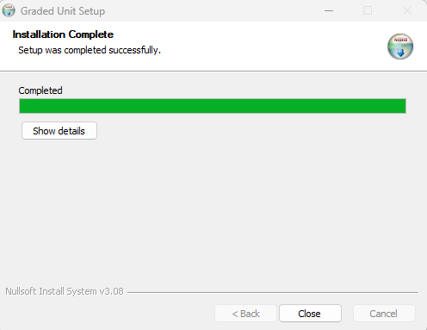

Upon opening the folder, you will see another folder called ‘Graded Unit’. Open this folder.

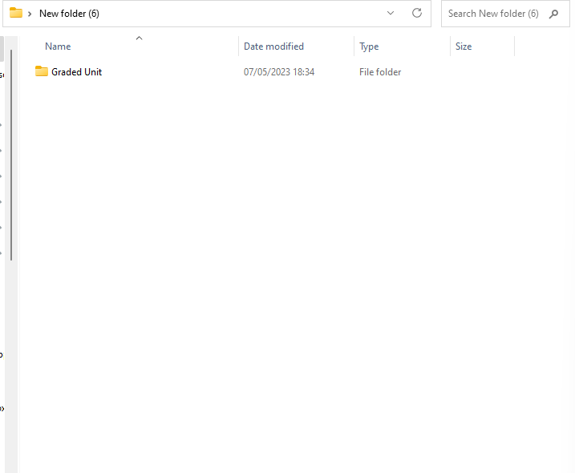

Finally double click on the main.exe file (This is the only file with the application type).

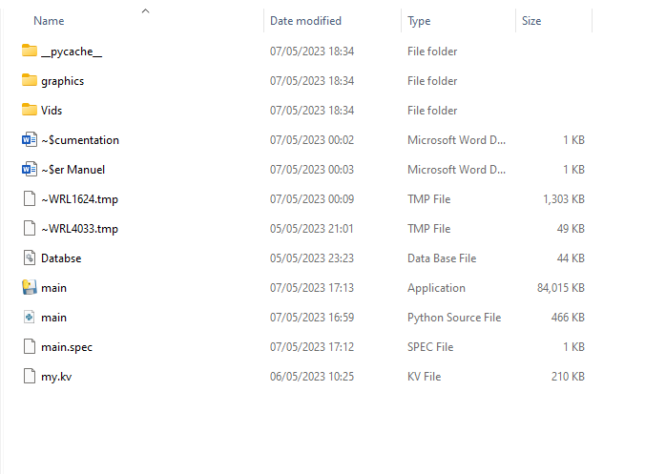

# Log In

Upon running the program, you will be taken to this screen. This is where returning users will log in, however, if you are a new user what you want to do is click the ‘create account’ button at the bottom of the screen.

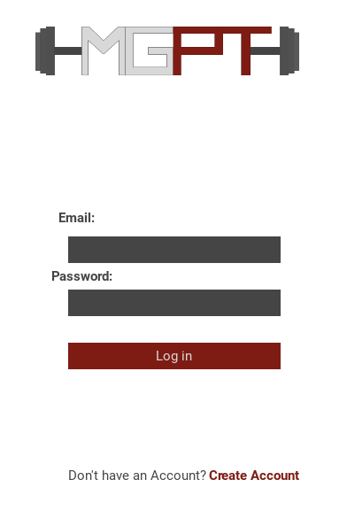

# Create Account

On the Create account screen you are required to fill three fields.

First you create a username, this can be anything, but we would recommend that it is relatable to yourself.

Second you enter you email address

And third you create a password, it is important that your password is secure, and then click the ‘sign up’ button.

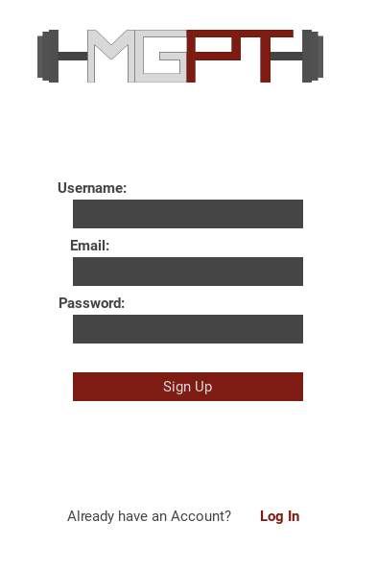

# Questions 1

Once you have created your account you will be asked to answer a few questions. It is important to remember that these questions are primarily for you to keep track of your progress and for us to determine your calories and what training plan would fit you the best. The First block of questions requires you to enter both your first and last name, your age and what gender you are. From there you select the’ next’ button.

# Questions 2

The second Block of Questions includes what level you are at and what your activity level is. First, ‘what level you’re at’ refers to what your experience is with exercise, whether that be in a gym, at home or wherever. Your ‘activity level’ refers to your overall fitness level, this will include things, such as, if you exercise, walk, train, whether or not you get your recommended 10,000 steps a day. From there you select the ‘next’ button.

# Questions 3

The Third Block of questions include where you will be training and what equipment you have. Where you’ll be training is self-explanatory, you select either ‘gym’ or ‘home’ depending on where you’ll primarily be training. What equipment lets us know what you have available to you so that we can tailor sessions to your availability. For example, if you will be training at a gym you’ll most likely select ‘most’ or ‘some’ and if you’re training at home you’ll most likely select ‘only dumbbells’ or ‘no equipment’. From there you select the ‘next’ button.

# Questions 4

The Fourth block of questions include how many days a week will you be training, your weight and your height. First, you’ll select roughly how many days a week you’ll be training, don’t worry if this ends up changing this is just to give us an idea of your schedule/availability. Second you enter your height you can either enter this in centimetres or in feet and inches. If you choose to enter it in feet and inches you need to enter it in the format ‘6.3’ if your height was 6 foot 3 inches or ‘5.11’ if your height was 5 foot 11 inches for example. Finally, you should enter your weight, you can enter this in either in kilograms or in pounds(lbs). From there you select the ‘next’ button.

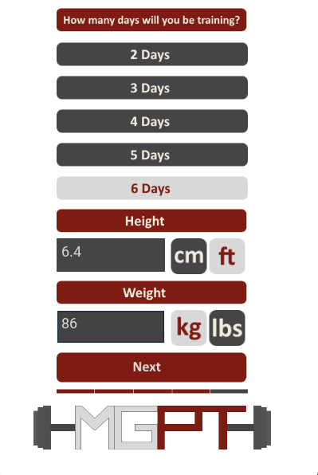

# Questions 5

The Fifth and final block of questions includes a table of goals. For this we want you to rank the following goals: Lose Weight, Build Muscle, Maintain Weight and Gain Weight. For these goals we want you to rank them from 1-4, 1 – being the highest priority and 4 – being the lowest priority. Don’t worry if you think that by selecting ‘maintain weight’ at 3 when your goal is to lose weight is going to contradict your goal. We are aware of this thought process; the 1 and 2 ranked goals are the most relevant to our calculations.

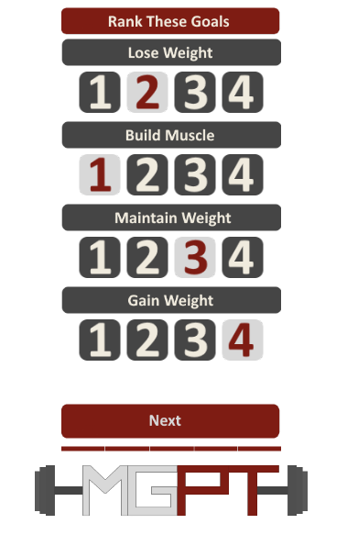

# Results

The results include your daily recommended calorie intake, which will be included in the profile. The results also includes a recommendation for what you can use for to track your calories.

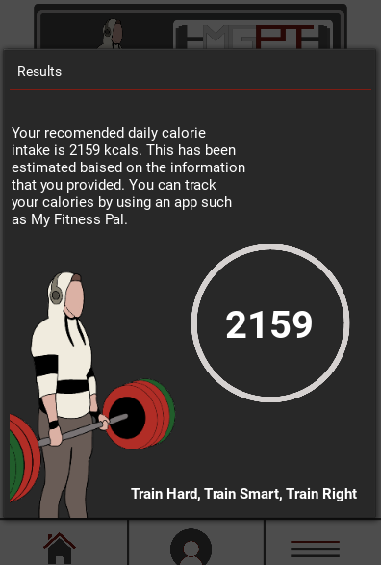

# Home

## Pt Session

The’ Pt session’ button will take you to the personal trainers website, from there you will have access to prices and contact information.

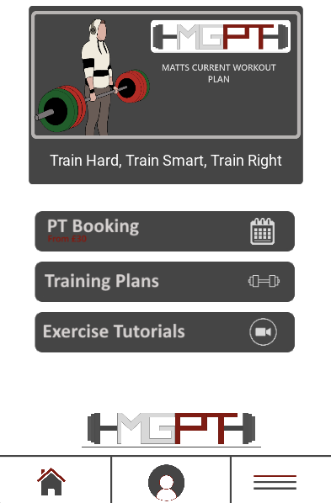

# Training Plans

In the training plan window, you will be presented with three options Featured, Gym and Home. Although the training plans are filtered to Gym and Home this doesn’t mean that they cannot be utilised in either location, this is just our recommendation.



## Featured

The Featured tab includes the current featured training plan, this will change monthly with a brand new ‘featured’ program. As of right now it is ‘Matts Current Plan’.

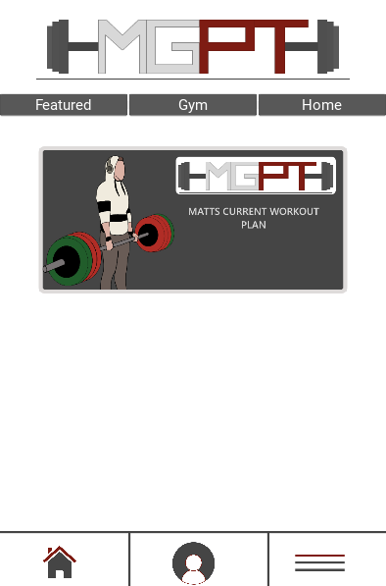

## Gym

The Gym tab includes training plans that are most suitable for the gym. In here we offer a selection of training plans. It is important to know that although there are ‘rep’ and ‘set’ ranges these are only recommendations to be used as a reference or guide, you don’t have to stick to them as we want you to push and test yourself to succeed.

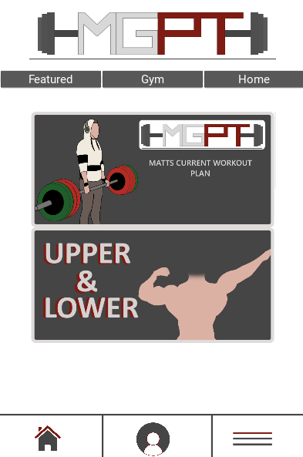

## Home

The Home tab includes training plans that are most suitable at home. Included are a variety of different sessions from HIIT sessions to full body sessions. These plans can be performed in the gym, and they can also be modified depending on what equipment you have at your disposal. But most of these plans have been set up with the intention that the user will have little to no equipment.

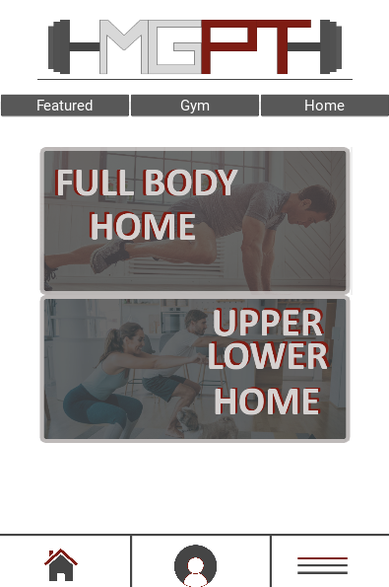

## How To Use

Upon selecting a training plan, you are first presented with a small description of what the training plan includes. You have a selection of sessions in the tabs at the top. Clicking on a session will provide you with the exercises, recommended warm up sets, working sets and rep ranges. Now if you are not sure what an exercise is or if you don’t know how to perform the exercise properly you can click on the ‘exercise’ button. This will provide you with the exercise tutorial directly, this prevents you from having to go all the way to the exercise tutorial section and trying to find the exercise.

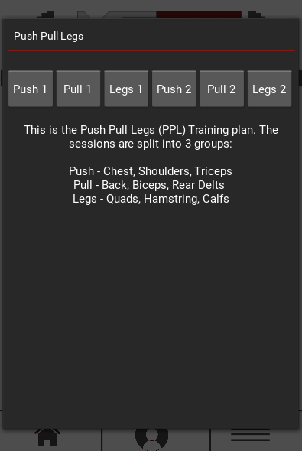

# Exercise Tutorial

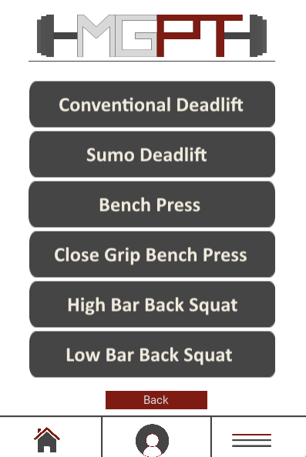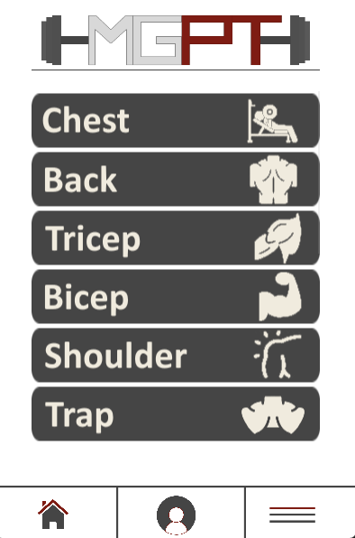The exercise tutorial screen gives you tutorials for all of our available exercises. As of right now we have over 100 exercises and growing. Currently we don’t have video tutorials for all of our exercises, however, we made sure that the ‘staple’ and ‘compound’ exercises have video demonstrations. The exercises that don’t have a video demonstration yet, have a written description which will be combatted with the video in the near future. The user can browse freely through our selection of exercises which is filtered into muscle groups and learn how to perform them easily and effectively.

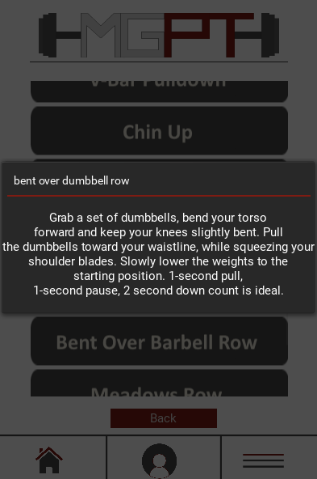

# Profile

The Profile includes the important user information that was entered at the start. This includes username, first and last name, email address, weight, height, and daily recommended calorie intake.

# Settings

The settings only incudes two options, one of them being logging out and the other being our privacy policy. The privacy policy reiterates how we use the information that you entered.

